

**Capstone Project**

**(University DataBase Management System)**

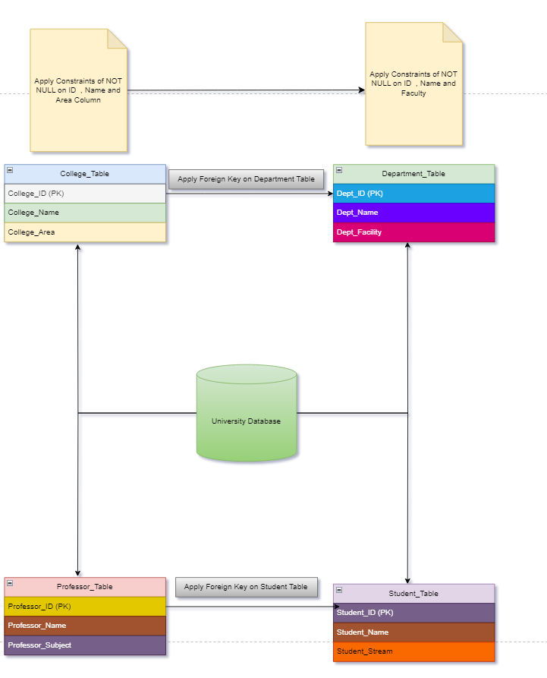

University Database Management System is one of the Fundamental and Intermediate level SQL project

Here in this Project you have to create an efficient DBMS for the any University .

Inorder to create this system Perform the following task:-

**Task 1:-**

1.Create University Database give any University name you want

CREATE DATABASE University_DB;

USE University_DB;

2. Under this University Create four tables and each table should have following three Column named as:-

A. College_Table

College_ID(PK)

College_Name

College_Area

CREATE TABLE College_Table (

College_ID INT PRIMARY KEY,

College_Name VARCHAR(100) NOT NULL,

College_Area VARCHAR(100) NOT NULL

);

B. Department_Table

Dept_ID(PK)

Dept_Name

Dept_Facility

CREATE TABLE Department_Table (

Dept_ID INT PRIMARY KEY,

Dept_Name VARCHAR(100) NOT NULL,

Dept_Facility VARCHAR(100) NOT NULL,

College_ID INT

);

C. Professor_Table

Professor_ID(PK)

Professor_Name

Professor_Subject

CREATE TABLE Professor_Table (

Professor_ID INT PRIMARY KEY,

Professor_Name VARCHAR(100) NOT NULL,

Professor_Subject VARCHAR(100) NOT NULL

);

D. Student_Table

Student_ID(PK)

Student_Name

Student_Stream

CREATE TABLE Student_Table (

Student_ID INT PRIMARY KEY,

Student_Name VARCHAR(100) NOT NULL,

Student_Stream VARCHAR(100) NOT NULL,

Professor_ID INT

);

3. Apply foreign key on Department key from College_table.

ALTER TABLE Department_Table ADD CONSTRAINT FK_College_Department FOREIGN KEY (College_ID) REFERENCES College_Table(College_ID)

4. Apply foreign Key on Student_Table from Professor_Table

ALTER TABLE Student_Table ADD CONSTRAINT FK_Professor_Student FOREIGN KEY (Professor_ID) REFERENCES Professor_Table(Professor_ID)

5. Insert atleast 10 Records in each table

INSERT INTO College_Table (College_ID, College_Name, College_Area) VALUES

(1, 'Engineering College', 'North Campus'),

(2, 'Arts College', 'South Campus'),

(3, 'Science College', 'West Campus'),

(4, 'Management College', 'East Campus'),

(5, 'Law College', 'Central Campus'),

(6, 'Medical College', 'North East Campus'),

(7, 'Architecture College', 'South East Campus'),

(8, 'Design College', 'Central West Campus'),

(9, 'Agriculture College', 'South West Campus'),

(10, 'Pharmacy College', 'East West Campus');

INSERT INTO Department_Table (Dept_ID, Dept_Name, Dept_Facility, College_ID) VALUES

(1, 'Computer Science', 'Lab Facility', 1),

(2, 'Mechanical Engineering', 'Workshop Facility', 1),

(3, 'Physics', 'Research Labs', 3),

(4, 'Chemistry', 'Research Labs', 3),

(5, 'Business Administration', 'Conference Rooms', 4),

(6, 'Economics', 'Library Access', 2),

(7, 'Biotechnology', 'Advanced Labs', 6),

(8, 'Design', 'Studios', 8),

(9, 'Law', 'Court Rooms', 5),

(10, 'Pharmacy', 'Medicine Labs', 10);

INSERT INTO Professor_Table (Professor_ID, Professor_Name, Professor_Subject) VALUES

(1, 'Dr. Smith', 'Artificial Intelligence'),

(2, 'Dr. Taylor', 'Thermodynamics'),

(3, 'Dr. White', 'Organic Chemistry'),

(4, 'Dr. Green', 'Quantum Physics'),

(5, 'Dr. Brown', 'Microeconomics'),

(6, 'Dr. Black', 'Civil Law'),

(7, 'Dr. Adams', 'Pharmacology'),

(8, 'Dr. Lee', 'Interior Design'),

(9, 'Dr. Allen', 'Agronomy'),

(10, 'Dr. Harris', 'Data Structures');

INSERT INTO Student_Table (Student_ID, Student_Name, Student_Stream, Professor_ID) VALUES

(1, 'Alice', 'Computer Science', 1),

(2, 'Bob', 'Mechanical Engineering', 2),

(3, 'Charlie', 'Organic Chemistry', 3),

(4, 'David', 'Quantum Physics', 4),

(5, 'Eve', 'Microeconomics', 5),

(6, 'Frank', 'Civil Law', 6),

(7, 'Grace', 'Pharmacology', 7),

(8, 'Hank', 'Interior Design', 8),

(9, 'Ivy', 'Agronomy', 9),

(10, 'Jack', 'Data Structures', 10);

**Task 2:-**

1. Give the information of College_ID and College_name from College_Table

SELECT College_ID, College_Name

FROM College_Table;

1. Show Top 5 rows from Student table.

SELECT *

FROM Student_Table

LIMIT 5;

1. What is the name of professor whose ID is 5

SELECT Professor_Name

FROM Professor_Table

WHERE Professor_ID = 5;

1. Convert the name of the Professor into Upper case

SELECT UPPER(Professor_Name) AS Uppercase_Professor_Name

FROM Professor_Table;

1. Show me the names of those students whose name is start with a

SELECT Student_Name

FROM Student_Table

WHERE Student_Name LIKE 'A%';

1. Give the name of those colleges whose end with a

SELECT College_Name

FROM College_Table

WHERE College_Name LIKE '%a';

1. Add one Salary Column in Professor_Table

ALTER TABLE Professor_Table

ADD Salary DECIMAL(10, 2);

1. Add one Contact Column in Student_table

ALTER TABLE Student_Table

ADD Contact VARCHAR(15);

1. Find the total Salary of Professor

SELECT SUM(Salary) AS Total_Salary

FROM Professor_Table;

1. Change datatype of any one column of any one Table

ALTER TABLE College_Table

MODIFY College_Area VARCHAR(50);

**Task 3:-**

1. Show first 5 records from Students table and Professor table Combine

SELECT Student_ID AS ID, Student_Name AS Name, Student_Stream AS Stream_Subject

FROM Student_Table

LIMIT 5

UNION ALL

SELECT Professor_ID AS ID, Professor_Name AS Name, Professor_Subject AS Stream_Subject

FROM Professor_Table

LIMIT 5;

1. Apply Inner join on all 4 tables together

SELECT

C.College_ID, C.College_Name, C.College_Area,

D.Dept_ID, D.Dept_Name, D.Dept_Facility,

P.Professor_ID, P.Professor_Name, P.Professor_Subject,

S.Student_ID, S.Student_Name, S.Student_Stream

FROM College_Table C

INNER JOIN Department_Table D ON C.College_ID = D.Dept_ID

INNER JOIN Professor_Table P ON D.Dept_ID = P.Professor_ID

INNER JOIN Student_Table S ON P.Professor_ID = S.Student_ID;

1. Show Some null values from Department table and Professor table.

SELECT *

FROM Department_Table

WHERE Dept_Name IS NULL OR Dept_Facility IS NULL;

SELECT *

FROM Professor_Table

WHERE Professor_Name IS NULL OR Professor_Subject IS NULL;

1. Create a View from College Table and give those records whose college name starts with C

CREATE VIEW College_View AS

SELECT *

FROM College_Table

WHERE College_Name LIKE 'C%';

SELECT * FROM College_View;

1. Create Stored Procedure of Professor table whatever customer ID will be given by user it should show whole records of it.

DELIMITER //

CREATE PROCEDURE GetProfessorDetails(IN ProfessorID INT)

BEGIN

SELECT *

FROM Professor_Table

WHERE Professor_ID = ProfessorID;

END //

DELIMITER ;

CALL GetProfessorDetails(5);

1. Rename the College_Table to College_Tables_Data .

RENAME TABLE College_Table TO College_Tables_Data;